**USER REQUIREMENTS**

**App Assumptions:**

* The app will be written in Objective C.
* The app will include an administrator control panel. (update images, location ID’s, vendor ID's, business rules, etc) .
* The app will make API/Web service calls and receive data from:
  + Vendors (Dominoes, McDonald's, Target, etc).
  + GPS coordinates from user phone, user address, vendor address, Google API/Web service, etc.
* The app will integrate with best of breed eCommerce payment services.
* The app architecture will be scalable N-tier (presentation GUI layer, business rules layer, data layer).

**App System Requirements:**

* iOS 7 compatible device (iPhone, iPad, and iPod touch).
* iOS 7 or later.

**App Constraints/Restrictions:**

* Application will only register users with the specified EDU (business rules set in administrator cms/control panel).
* Some application functionality will be determined by location coordinates.

**App UX:**

* App UI customized to user hardware (color schemes, affordance, functionality, etc).
* App UI to include collection of UI themes to correlate to the colors of the iPhone 5C (and therefore the iPod Touch series).
* App UI to utilize color as affordance: (Use color to indicate actions. app examples: Mailbox and Shake).
* App UI to utilize layers and depth.
* App UI to utilize parallax (see app example: Hatch).
* App UI to utilize Blur.
* App UI to utilize clean, simple, yet unique methods of transitioning.
* App UI to utilize well designed command buttons.

**App Development Scheduling:**

* Please provide due dates for each testing phase.

**Project will include a custom content management/administrator control panel to manage:**

* Products
* Vendors
* Employees
* Locations
* Location Coordinates
* App Business Rules
* Etc.

**(Example)**

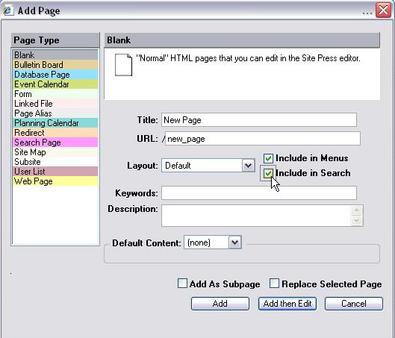

**App must determine customer location to determine if customer is within pre-defined radius.**

**If customer is within pre-defined radius, then app will display pre-defined vendors.**

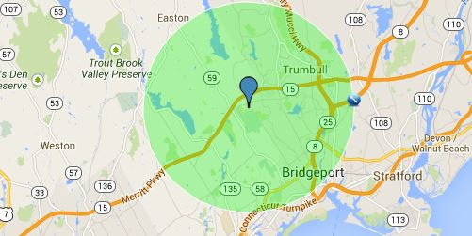

**APP FLOW**

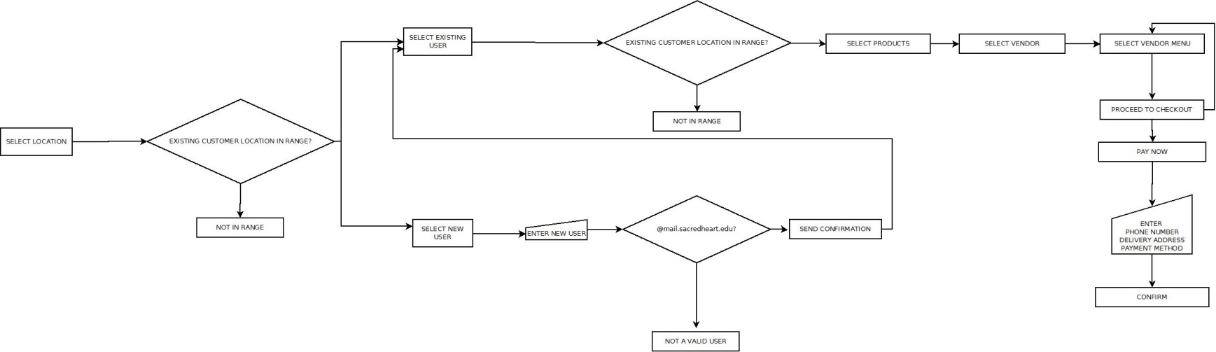

APP DATABASE ERD

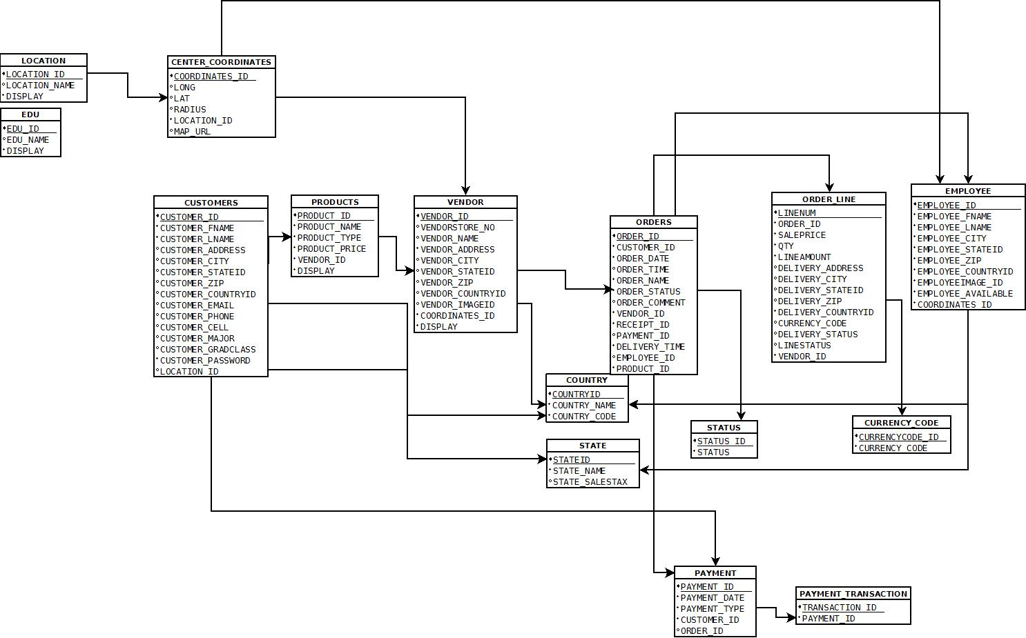

*Table definitions and column names provided in spreadsheet “FulFillAPP_DB.xlsx”*

**SCREEN 1.**

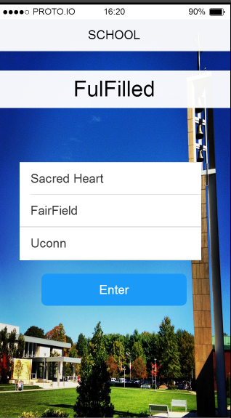

**Purpose: User selects an ADMINISTRATOR DEFINED geographical location.**

Functions

-Each “geographical location” is currently a list of schools. This list is scrollable and clickable.

-For now, the screen should only show “Sacred Heart University”. Administrator can display additional schools via “DISPLAY” option in web-based control panel. (table: location)

-Once geographical location is selected, the location will be used for the CURRENT SESSION ID.

-User clicks enter to proceed to SCREEN 2🡪

**SCREEEN 2.**

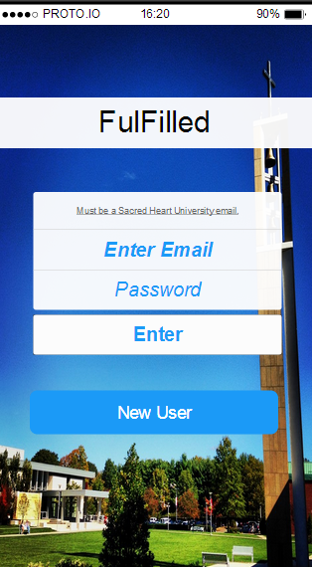

**Purpose:**

* **Enter username and password and LOGIN**
* **Click Forgot username or password**
* **Click NEW USER**

Functions

-Click “New User” button to proceed to SCREEN 3🡪

-Registered users login to proceed to SCREEN 4🡪

**SCREEN 3.**

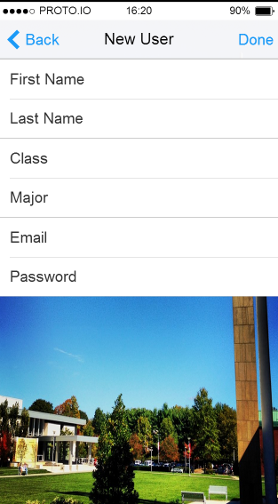

**Purpose: Create new user.**

Functions

-Allow user to manually enter the data required to become a registered user of App FulFilled.

Data:

* First Name
* Last Name
* Password: (display password as *******)
* Email (drop down from table: EDU for rows that are enabled via web-based control panel).

-When complete user, will be returned to SCREEN 2 🡨to LOGIN.

**SCREEN 4.**

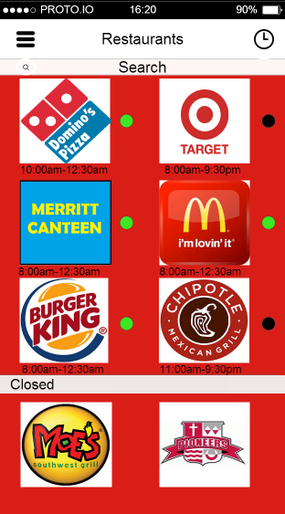

**Purpose: Display vendors located within predefined geographical location.**

Functions

-App will display vendors within location range of CURRENT SESSION ID. (Determined in SCREEN 1) **but for only the vendors where a vendor record exists in table “vendors”.** (“vendors” will be predefined via web-based administrator control panel.)

-Vendors includes- Sacred Heart University, Dominos, Pizza Hut, Papa Johns, Primo Pizza McDonalds, Burger King, Wendy’s duchess, Five guys burger & fries, Chipotle, Moes, Taco Bell, Qdoba, Merritt Canteen, Stop and Shop, Target, Subway, Panera Bread, Starbucks, Dunkin’ Donuts, KFC, Pop Eyes, Boston Market, Panda Express. Etc.

-Vendors not available via API will come from vendor table.

-“Search” options allows users to search for a specific vendor.

-OPEN Vendors appear on top. CLOSED vendors appear on bottom. (Open and closed times should be data retuned by vendor API OR vendor website). OPEN vendors are enabled (clickable). CLOSED vendors are disabled.

-When user clicks icon, on top right of screen, the screen will display vendors of previous orders.

-If Phone is turned horizontal it will show each vendor individually. 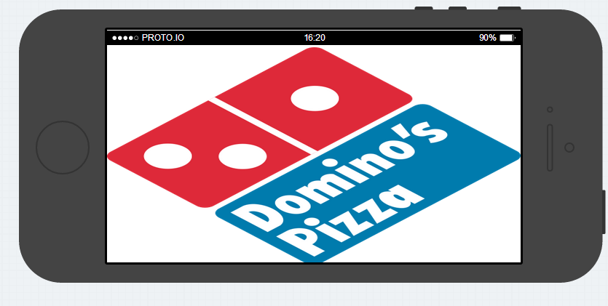

-When user clicks  icon a PRODUCTS LIST will appear. (SCREEN 4A)

-Tap vendor icon to proceed to vendor menus in SCREEN 5.

**SCREEN 4A.**

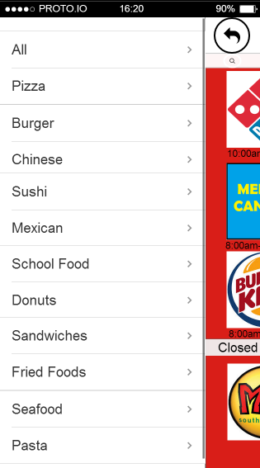

**Purpose: Display list of vendor product ID’s so user can filter vendors based on product ID’s. .**

Functions

-Web-based administrator control panel determines Product ID’s.

-When user selects products, SCREEN 4 will show only vendors that offer those products.

**SCREEN 5.**

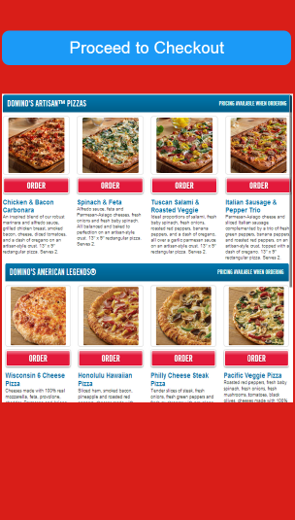

**Purpose: Display the selected vendor menu items.**

Function

-Display the menu items including pricing for selected vendor.

-Allow user to select vendor products (line items) Pizza, burger, coke, etc.

-Products and pricing for vendors not available via API will come from products table.

-Click “Proceed To Checkout” to proceed to SCREEN 6🡪

**SCREEN 6.**

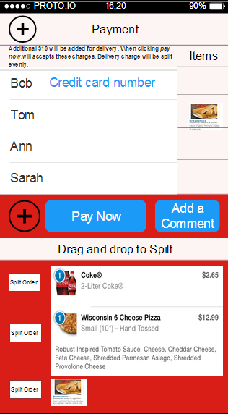

**Purpose: Allow user to purchase vendor menu items AND give user ability to SPLIT the cost of line item between multiple credit cards. (Split the order).**

Functions

-Vendor line item charges should be added to order.

-“Service charge” line item should be added to order.

-“Delivery charge” line item should be added to order.

-“Sales tax charge” line item should be added to order.

-Service charge, delivery charge, and sales tax values are maintained via web-based administrator control panel.

- When user clicks the  icon, user proceeds to SCREEN 7 to pay for line item using additional credit card.

- Line item charges can be split and charged to different credit cards via drag and drop functionality.

-If only one credit card, then order is charged to that 1 credit card.

- When user clicks  button, user can manually enter comment for the order.

-When user clicks the  icon, user will return to SCREEN 5 🡨 to order more menu items.

-When user clicks “Pay Now” user will be sent to SCREEN 7🡪

**SCREEN 7.**

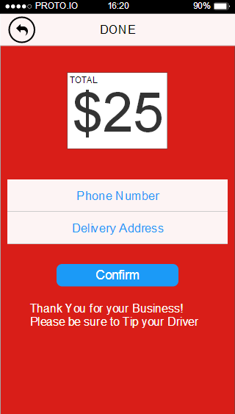

**Purpose: User manually enters phone number and delivery address and confirms order.**

Functions

-Display grand total of order including service and delivery charges and sales tax.

-If delivery address not in range, return message:

“DELIVERY ADDRESS NOT IN DELIVERY RANGE. PLEASE ENTER NEW ADDRESS”.

-Once user clicks “Confirm”, the app transactions process will begin.

-A “delivery notification” with the details of the delivery, will be sent to EMPLOYEE assigned to order.

**SCREEN 9.**

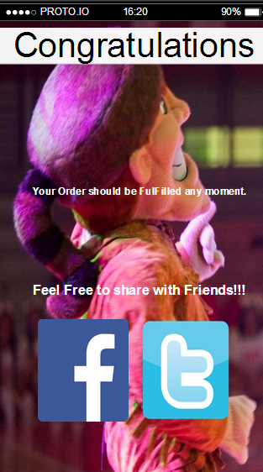

**Congratulations screen**

Functions

-Screen thanking the costumer

-Being able to share with friends on social media.

**NOTES:**

-Message notifications (OUT OF DELIVERY RANGE, etc should be pop ups.

-The app will integrate with best of breed eCommerce payment services.

-If API not available, use other options to retrieve vendor menu and pricing data from vendor.